COPY: Everyone feels like a VIP when they walk through an automatic door – whether you’re strutting, sashaying, or just plain in a hurry … keep walking, we’ll get the door! 🚶‍♀️ 🚶‍♂️🚶 Give customers an opportunity to make a grand entrance with automatic doors and mark your calendar to bask in all their glory, #AutomaticDoorDay is March 19th!
Image:
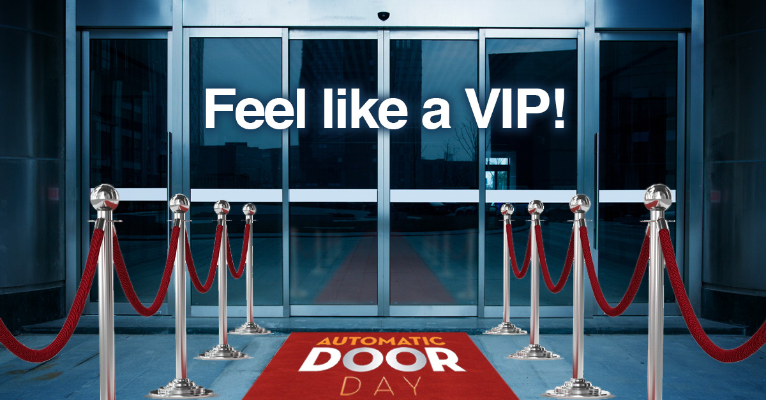

COPY: Ever seen any Star Wars or Star Trek movies? 🙋‍♂️ All the doors and entrances throughout these films are automatic! They’re the doors of the future and don’t shut anyone out, creating universal access to public buildings for all – that’s why we celebrate them on #AutomaticDoorDay on March 19th!
Image:
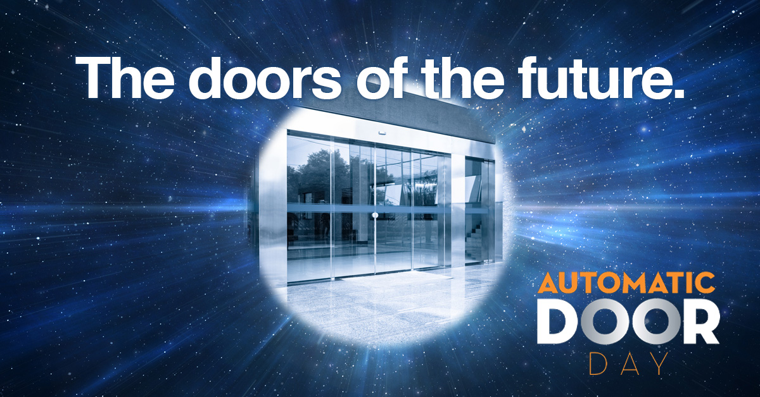

COPY: 🗣️ Give the people what they want – automatic doors! It’s the entrance 98.9% of consumers prefer and it’s totally germ-free, to boot! Pretty neat, eh? That’s why we’re celebrating them for #AutomaticDoorDay on March 19th and we hope you do too!
Image:

